**AP16 Test Project Document**

**Database Design**

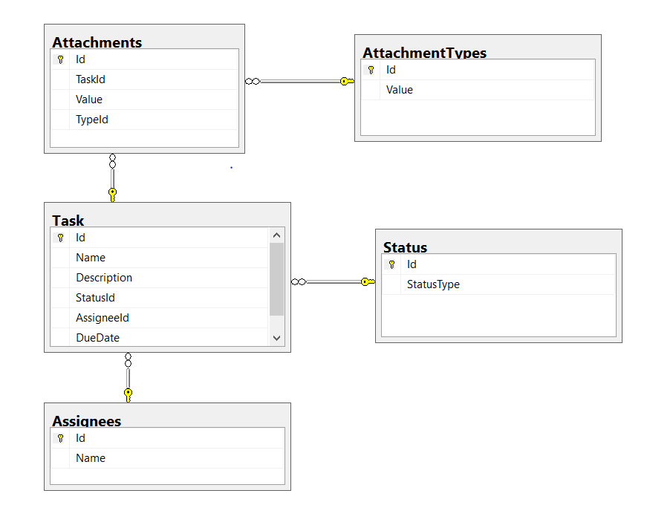

1. In this test project I Used ADO.NET Framework using DAPPER ORM to connect to Datebase. I implement ADO.NET helper project called ADONETHelper which can be used to make connection to SQLSERVER, MYSQL, ACCESS AND any other db that supports System.Data.Common and implements DbConnection , DbCommand etc
2. There are many Object Relational Mapping available like LinqToSql and EntityFrameWork. But they have own pros and cons. Using custom ORM has many adavantages like Efficient, Scalability, UnitTestable etc.
3. In this project I used Service Oriented Architecture. There is UI Layer and Service Layer (WEBAPI) and in service layer is comprised of BLL(Business Logic Layer) and DAL(Data Access Layer). And there are some factory classes like ADONETHelper to make connection to database and HTTPHelper project to make HTTP WebRequests to WEBAPI. This Project follows Inversion Of Control pattern using Dependency Injection. MSUnity (unity.mvc, unity.webapi) framework is used to achive Dependency Injection. I would also consider unit testing and integration testing functionality wherever applicable
4. I would ask them What devices customer want to target (PC, Mobile or Tablet), how many number of users.